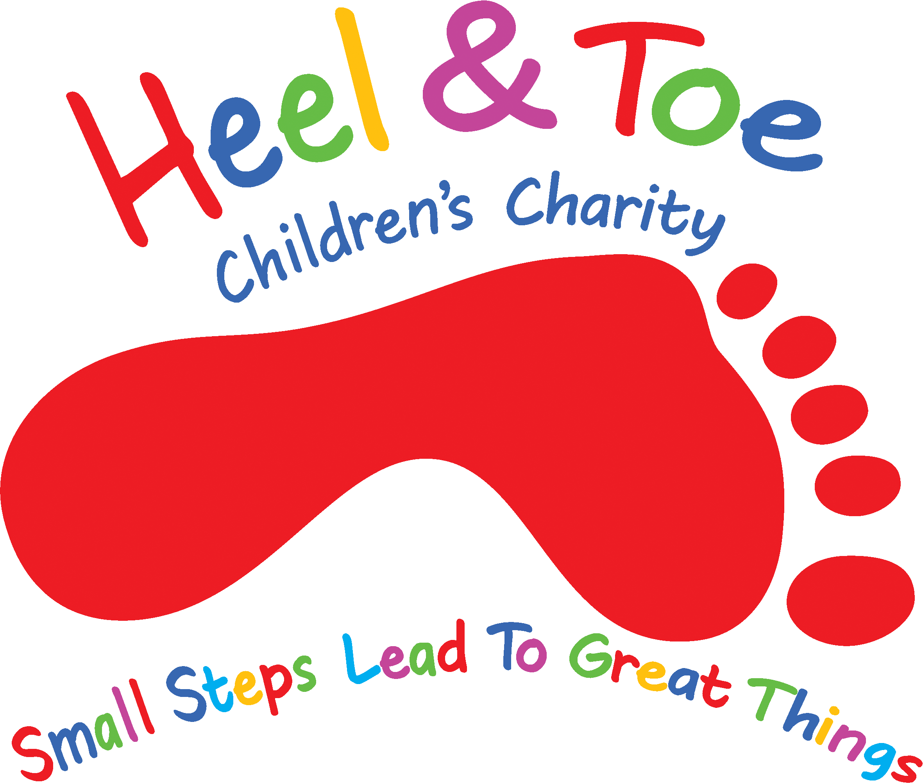

**Heel & Toe Total Warrior Information**

**Leeds Bramham Park, Wetherby, LS23 6ND**

**Saturday 21st June 2024**

We are delighted to invite you to join the Total Warrior Team.

Total Warrior is a 12k obstacle race with 25 obstacles, 10 tons of ice and 100 tons of mud! Entry includes FREE transport from Stanley Travel to and from the event (optional), Heel and Toe t-shirt, total warrior finishers t-shirt, a victory beer, a total warrior headband, and total warrior goodies. We also have a tent in the charity village, offering snacks and refreshments after the course.

The scheduled pick-up is 8am from the Heel & Toe Centre, 40 Front Street, Pelton, Chester le Street, DH2 1DE. Please be aware that alcohol is not permitted whilst on the coach.

All participants must be at least 16 years of age.

As we have a limited number of places available, we would ask you to please return the enclosed entry form and **£25.00** non-refundable registration fee by **Monday 3rd March 2025** to ensure your place in the Total Warrior 2025.

We are asking those interested to make a commitment to raise a minimum of **£149.00** sponsorship (lowered to £125 for a group of 6 or above) for Heel & Toe. This needs to be raised/paid by **Friday 18th July 2025.**

This looks set to be a very exciting day and I hope you can join us. If you should require any further information, please contact me on 0191 386 8606 or email:

Kind regards,

**Natalie Duncan**

**Fundraising Manager**

**Email:** [**natalie@heelandtoe.org.uk**](mailto:natalie@heelandtoe.org.uk)

**Telephone: 0191 3868606**



**Heel and Toe Children’s Charity**

**Total Warrior 2025 Entry Form**

**Reg Charity No 1125695**

|  |
| --- |
| **PERSONAL DETAILS**  Title (Mr/Miss/Mrs):_______ First Names:_____________Surname: ___________________  Address:_________________________________________________________________________________________________  ________________________________________________________________________________________________________  Postcode:____________________________  **ALL APPLICANTS MUST BE AGED 16 OR OVER ON THE DAY OF THE EVENT.**  Home telephone number:___________________________ Mobile number:_________________________________________  Email address:_________________________________________________ (I am happy to receive emails from Heel and Toe) YES/NO  Are you taking part in this event for a child at Heel and Toe? YES/NO  If yes, please state name of child**?** _________________________________________________________  Do you have a medical condition which the organisers should be made aware of? YES/NO  Please indicate your t-shirt size Small/Medium/Large/X Large/XX Large  Will you be travelling with Heel and Toe on the FREE coach? Yes No  Are you a UK tax payer and agree for gift aid to be claimed on your sponsorship total? ­­­­­­__________ |

|  |
| --- |
| **ENTRY**  I understand that by having a place with the charity I need to pay a £25.00 non-refundable registration fee at the time of submitting this application and that I will raise a minimum of £149.00 in sponsorship. |

|  |
| --- |
| **PAYMENT**  You can pay via our website [www.heelandtoe.org.uk](http://www.heelandtoe.org.uk)  Pay via your bank, use REF TWR 2025 (your name). Our details account 33455904 sort code 20-27-41  Send us a cheque for £25.00 payable to Heel & Toe  You can pay by calling us on 0191 386 8606 and pay using chip and pin |

|  |
| --- |
| **SIGNED**____________________________ **DATE_____________________** |

Please return your application form to Natalie Duncan at Heel & Toe Children’s Charity, 40 Front Street, Pelton, DH2 1DE. 0191 3868606. Alternatively, you can email the completed application form to [natalie@heelandtoe.org.uk](mailto:natalie@heelandtoe.org.uk).

**GIFT AID**

Unless you object, when we receive your sponsorship we will claim gift aid on your behalf. By claiming gift aid, the charity receives an extra 25p from every £1 that you have raised on top of your total amount.

**DISCLAIMER**

I have read the terms and conditions of entry and acknowledge that the organisers shall not be liable for death, personal injury or loss or damage as a consequence of my participation in the Total Warrior 2024 except with regard to personal injury which is caused by the organiser’s negligence. Should I not reach my £149.00 sponsorship target, I agree personally to cover the deficit. I also confirm that I will meet all the deadlines for required sponsorship raised as stated in the Total Warrior Information Sheet. Please note, your £149.00 sponsorship commitment does not include your gift aid. Your sponsorship amount is purely your donations collected, gift aid is then an added bonus from the government.